INTERNATIONAL CONFERENCE

“The unemployed and the working poor in the age of crisis.
The challenge of social inclusion”

Date: Thursday 16 July 2009
Venue: Titania Hotel, Athens

9:00 - 9:30 | REGISTRATION
9:30 - 10:00 | INTRODUCTION TO THE DEBATE-OPENING SPEECHES
 | Introduction to the International Conference-Debate |  | Prof. Theodoros Sakellaropoulos, EPEKSA President
 | Opening Speeches |  | Ministry of Education (tbc)
 |  |  | Ministry of Employment (tbc)
 |  |  | Mr. Dimitris Reppas, former Minister of Employment & Social Affairs, MP (tbc)
10.00- 11. 00 |  | 1st SESSION: SETTING THE CONTEXT
 |  | Coordinator: Prof. Theodoros Sakellaropoulos
10.00 – 10.15 |  | Introduction to the Open Method of Coordination and the 2010 European Year for Combating Poverty and Social Exclusion | Mrs. Marie-Anne Paraskevas, DG Employment, Social Affairs and Equal Opportunities
10.15 – 10.30 |  | Title (tbc) | Mr. Dimitris Kontos, Secretary General, Ministry of Employment and Social Affairs
10.30 – 10.45 |  | The unemployed and the working poor in the EU-27 | Mr. Ramon Pena-Casas, Observatoire Social Europeen, Belgium
10.45 – 11.00 |  | Discussion
11.00 – 11. 30 |  | Coffee Break
11.30 – 13.30 |  | 2nd SESSION: THE GREEK EXPERIENCE
 |  | Coordinator: Journalist (tbc)
11.30 – 11.45 |  | The Greek Experience | Mr. Nikos Ntasios, Hellenic Anti-Poverty Network
11.45 – 12.00 |  | The Greek Experience | Mr. Lambros Mihos, Municipality of Aghia Varvara
12.00 – 12. 15 |  | The Greek Experience | Mr. Georgios Romanias, GSEE-Confederation of Greek Trade Unions
12.15- 12. 30 |  | The Greek Experience | Mrs. A. Kalavanou, Greek Ombudsman
12.30 – 12.45 |  | The Greek Experience | Mrs. A. Kovaiou, NGO “Solidarity” (Hellenic Orthodox Church)
12.45 – 13. 00 |  | The Greek Experience | Mr. Kostas Geormas, Greek Representative at SPC
13.00 – 13.30 |  | Discussion
13.30 – 14.30 |  | Lunch
14.30 – 15.45 |  | 3rd SESSION: THE EUROPEAN EXPERIENCE
 |  | Coordinator: Mr. Tzanetos Antypas, PRAKSIS President
14.30 – 14.45 |  | The European Experience | Mrs. Lydie Gaudier, NGO “Pour la Solidarite”, Belgium
14.45 – 15. 00 |  | The European Experience | Mr. Heiiki Hiilamo, Diaconia Church, Finland
15.00 – 15.15 |  | The European Experience | Mark Byrne, European Anti-Poverty Network- Ireland
15.15 – 15. 45 |  | Discussion
16.00 – 16. 30 |  | CLOSSING SESSION: EVALUATION
 |  | Identifying key messages and issues at stake | Mrs. Marina Angelaki, EPEKSA-Project Coordinator

The Debates are co-organized by NGO-PRAKSIS, the Institute for Youth, NGO-Hellenic Anti-Poverty Network, NGO-Life Line Hellas, NGO- European Network of Women, NGO- Greek Forum for Migrants and NGO- Disability Now.
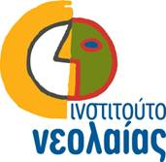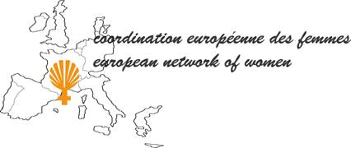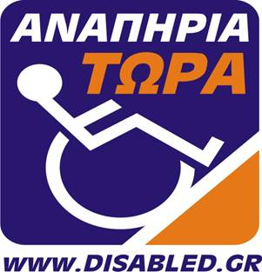

The Programme is supported by the European Community Programme for Employment and Social Solidarity (2007-2013) (80%) and the Institute for Youth (20%).



Employment, Social Affairs and Equal Opportunities DG
Social Protection and Integration
Inclusion, Social Policy Aspects of Migration,
Streamlining of Social Policies

